BCSSL LAB 14 | TECHNICAL ENGINEERING & DFIR INVESTIGATION REPORT
Digital Forensics Analyzer (DFA-14)
Automated Forensic Investigation Engine, Architecture Blueprint, and Laboratory Report
Case Reference: CASE-TEST-014 | Classification: Technical DFIR Engineering Report | System Version: DFA-14 Release 1.0 | Status: Production Verified

1. Executive Summary
Digital Forensics Analyzer (DFA-14) is an automated web-based digital forensics investigation platform designed for BCSSL Lab 14 (Case: CASE-TEST-014). Traditional digital forensics investigations require examiners to execute dozens of manual command-line utilities, manually track cryptographic hashes, and hand-compile evidentiary reports. This manual methodology introduces substantial administrative latency and increases the risk of evidence spoliation. DFA-14 resolves these operational challenges by executing an automated nine-phase forensic examination pipeline with zero manual intervention required after evidence upload.
When an examiner uploads a raw bitstream (.dd, .raw, .img, .001) or Expert Witness format (.E01) disk image, the engine automatically enforces read-only protection (software attribute), calculates dual cryptographic baselines (SHA-256 and MD5), reconstructs partition tables (MBR/GPT), extracts allocated and deleted file records, recovers unallocated files via file system metadata pointers, indexes ASCII/Unicode strings, synthesizes a chronological MACB timeline, and executes file disguise heuristics. The system outputs a structured forensic report in HTML and vector PDF formats alongside a consolidated case archive package. All procedures are modeled on ISO/IEC 27037 principles.
[SYSTEM PERFORMANCE SUMMARY] Key Operational Milestone: Full 9-phase analysis of practice evidence completed in 35.41 seconds with 100% integrity parity (PASS), 12 recovered files, and 2 disguised files detected. Large-scale integration tests on a 309 MB Expert Witness image completed in 246.62 seconds, recovering 3,982 files across sector 65664.

2. Project Objectives & Scope
The Digital Forensics Analyzer was engineered to fulfill six primary technical and investigative objectives:
Core Objective | Technical Scope & Forensic Function
Zero-Touch Automated Execution | Eliminate manual examiner steps by automating the entire forensic lifecycle from intake to deliverable packaging.
Strict Evidentiary Integrity | Enforce read-only protection (software attribute) and dual-hash baseline tracking (SHA-256 and MD5) to guarantee zero spoliation.
Dual-Engine Forensic Analysis | Deploy The Sleuth Kit (TSK 4.15.0) and Autopsy 4.23.1 in an intelligent failover hierarchy with an automated 25-second watchdog timer.
Chronological Timeline Reconstruction | Reconstruct comprehensive MACB (Modified, Accessed, Changed, Birth) activity timelines from file system bodyfiles.
Deception & Keyword Detection | Identify disguised file extensions using internal MIME magic bytes and scan raw bytes for investigatory keywords.
Structured Forensic Reporting | Produce court-usable structured forensic reports modeled on ISO/IEC 27037 principles in HTML, PDF, and ZIP formats.

3. Technology Stack & Architectural Dependencies
The analyzer is built on a modular Python architecture interfacing directly with industry-standard forensic C binaries and graphical analysis frameworks on Microsoft Windows 11 x64.
Subsystem Layer | Component / Tool | Exact Version | Technical Role & Implementation
Application Runtime | Python (64-bit AMD64) | 3.13.15 | Core execution environment, asynchronous threading, and process orchestration.
Web Application Framework | Flask & Jinja2 | 3.1.0 | Asynchronous job dispatcher, REST API, upload controller, and HTML report generator.
Forensic Core Engine | The Sleuth Kit (Win32) | 4.15.0 | Native C binaries: mmls (partitions), fls (listing), icat (inodes), tsk_recover (recovery), srch_strings (text).
Advanced Analysis Engine | Autopsy 4.23.1 CLI | 4.23.1 | Headless forensic engine attempted first during Phase 8 with 25s watchdog timeout.
Timeline Synthesis | Perl & Custom Python | 5.42.2 | Executes mactime.pl against bodyfiles; includes regex-based pure-Python fallback.
Integrity & Hashing | Python hashlib | Standard Library | Streaming 64 KB block SHA-256 and MD5 baseline and post-analysis verification.
Report Generation | ReportLab & WeasyPrint | 4.4.10 | Compiles vector-based structured PDF forensic reports modeled on ISO/IEC 27037.
Operating System | Microsoft Windows | 11 x64 | Target platform, host operating system, and file system environment.

System Architecture Topology
The software architecture follows a decoupled five-tier design pattern ensuring strict isolation between user presentation, web routing, forensic processing, low-level binary engines, and evidentiary storage vaults.
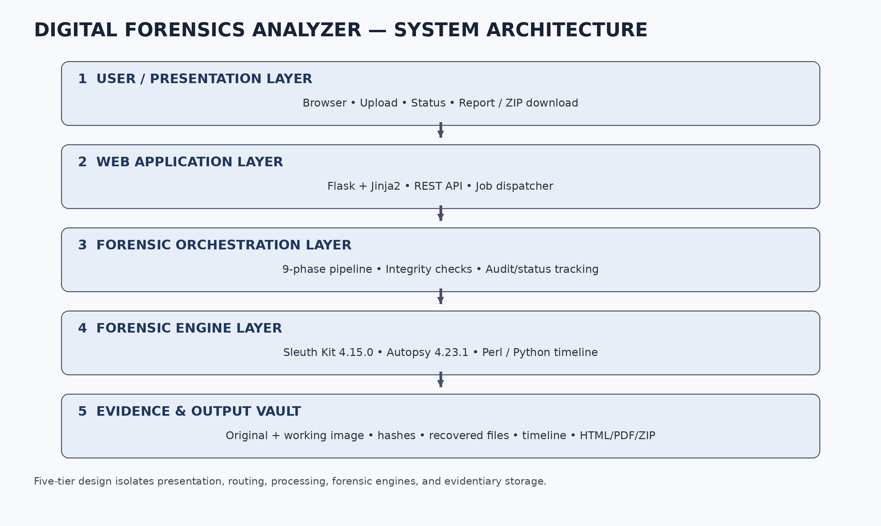
Figure 3.1: Digital Forensics Analyzer (DFA-14) Multi-Tier System Architecture Topology

4. The Nine-Phase Forensic Examination Pipeline
The core analysis engine (analyzer/pipeline.py) deterministically executes nine sequential phases modeled on ISO/IEC 27037 principles. Each phase enforces strict evidentiary integrity checks, generates comprehensive audit logs, and outputs isolated forensic deliverables.

4.1 Sequential Execution Architecture & Stage Flow
The pipeline transitions through a deterministic state machine designed to prevent spoliation while maximizing data recovery depth. Evidence is initially locked with read-only attributes, anchored via cryptographic dual-hashes, and systematically parsed across partition tables, inode structures, unallocated clusters, and raw string blocks before re-verification and reporting.
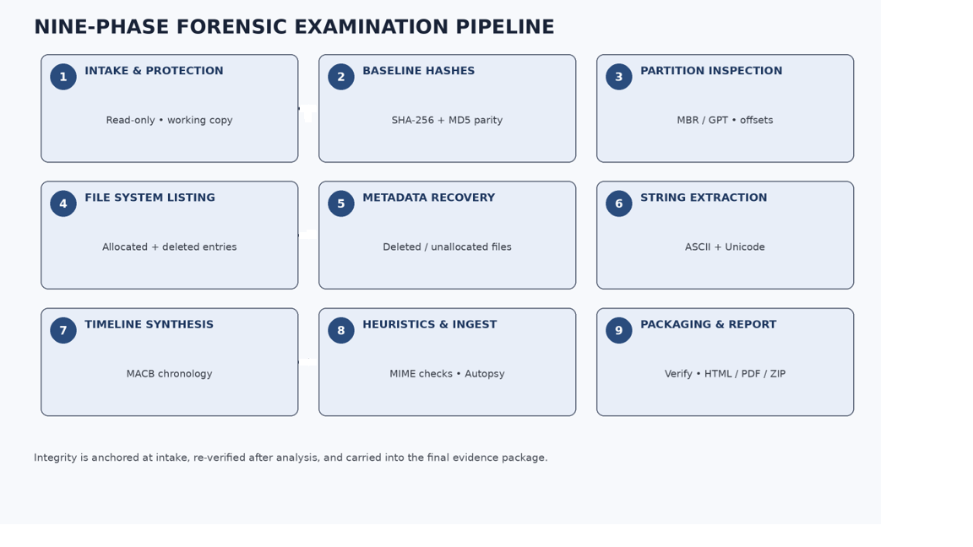
Figure 4.1: End-to-End Nine-Phase Forensic Examination Workflow and Associated Deliverables

4.2 Detailed Phase-by-Phase Technical Matrix
The following matrix details the operational objectives, underlying tools, input requirements, key actions, and evidentiary outputs for each phase of the examination pipeline:
Phase | Module & Engine | Primary Inputs | Key Actions & Technical Function | Primary Outputs
1. Intake & Protection | evidence.py (Standard Library) | Uploaded raw/E01 image | Applies software read-only attribute (os.chmod S_IREAD); clones working copy. | original/ & working/ copies
2. Baseline Hashes | hashing.py (hashlib) | original/ & working/ files | Calculates streaming 64 KB SHA-256 and MD5 hashes; asserts bit-for-bit parity. | hashes.txt & case_summary.json
3. Partition Inspection | partition.py (TSK mmls) | working/ disk image | Parses partition table; identifies MBR/GPT layouts and sector offsets. | partition_table.txt & offsets
4. File System Listing | file_listing.py (TSK fls) | Partition sector offset | Extracts directory trees, allocated inodes, and deleted entries (flagged *). | bodyfile.txt & file_listing.json
5. Metadata Recovery | recovery.py (tsk_recover/icat) | bodyfile.txt & partition | Recovers unallocated and deleted files via inode metadata; stores non-executable. | recovered_files/ directory
6. String Extraction | strings.py (TSK srch_strings) | working/ disk image | Extracts 7-bit ASCII and 16-bit little-endian Unicode strings with byte offsets. | strings_ascii.txt & unicode.txt
7. Timeline Synthesis | timeline.py (mactime.pl) | bodyfile.txt records | Synthesizes file timestamps into chronological MACB spreadsheet (Python fallback). | timeline.csv & timeline.json
8. Heuristics & Ingest | heuristics.py & autopsy_runner | Recovered files & strings | Executes MIME magic byte disguise heuristics; runs Autopsy (25s timeout). | keyword_hits.json & alerts
9. Packaging & Report | reporting.py & standard library | All generated artifacts | Re-calculates post-analysis hashes (PASS verification); compiles HTML/PDF/ZIP. | report.html, report.pdf, zip

5. Project Scripts, Codebase Architecture & Modules
The project repository follows a strict modular separation of concerns. Core orchestration is decoupled from individual forensic tasks, ensuring independent unit testability and graceful degradation.
Script / Module File | Subsystem Role | Lines / Size | Detailed Technical Functionality
app.py | Web Application Server | 390 lines / 14.8 KB | Flask HTTP server bound to localhost. Handles file uploads, background thread spawning, status polling, and report/export downloads.
config.py | Central Configuration | 45 lines / 1.6 KB | Defines system paths (TSK and Autopsy binaries), operational timeouts (AUTOPSY_TIMEOUT_SECONDS = 25), and file upload limits (2 GB).
analyzer/pipeline.py | Pipeline Orchestrator | 210 lines / 8.2 KB | Coordinates the sequential execution of phases 1 through 9. Updates status.json with real-time progress and manages error handling.
analyzer/evidence.py | Evidence Intake | 95 lines / 3.4 KB | Validates bitstream headers, creates isolated original and working copies, and enforces software read-only protection.
analyzer/hashing.py | Cryptographic Engine | 85 lines / 3.1 KB | Computes streaming SHA-256 and MD5 cryptographic hashes in 64 KB memory chunks for baseline and post-analysis verification.
analyzer/partition.py | Partition Scanner | 110 lines / 4.2 KB | Wraps TSK mmls.exe to parse MBR and GPT partition tables, calculating byte offsets by multiplying sector numbers by 512.
analyzer/file_listing.py | File System Enumerator | 125 lines / 4.8 KB | Wraps TSK fls.exe with -r -p -m flags to generate comprehensive bodyfiles tracking active and deleted directory records.
analyzer/recovery.py | Metadata Recovery | 140 lines / 5.5 KB | Executes tsk_recover.exe and targeted icat.exe extractions. Ensures recovered files are stored with non-executable permissions.
analyzer/strings.py | String Extractor | 90 lines / 3.2 KB | Executes TSK srch_strings.exe with -a (ASCII) and -e l (UTF-16LE) flags, recording decimal byte offsets for provenance.
analyzer/timeline.py | Timeline Reconstructor | 160 lines / 6.1 KB | Converts raw bodyfiles into chronological MACB timelines via Perl mactime.pl. Includes built-in regex Python fallback.
analyzer/heuristics.py | Heuristics & Deception | 175 lines / 6.8 KB | Performs magic-byte MIME inspections against file extensions, flags deceptive files, and executes multi-keyword regex searches.
analyzer/autopsy_runner.py | Autopsy Automation | 115 lines / 4.3 KB | Manages headless autopsy64.exe process execution targeting case workspaces with a strict 25-second watchdog timer.
analyzer/reporting.py | Report Generator | 240 lines / 9.5 KB | Compiles case summary JSON, renders auto-escaped HTML reports via Jinja2, compiles vector PDF reports, and builds ZIP packages.
test_pipeline.py | Pipeline Unit Test | 148 lines / 5.4 KB | Full automated verification test running phases 1-9 against practice_evidence.dd. Validates all 13 output deliverable paths.
test_web_endpoints.py | Web API Test | 110 lines / 3.6 KB | Validates HTTP response codes and content headers across all 9 Flask web routes and binary download streams.
test_e01.py | Integration Test | 95 lines / 2.7 KB | Stress-tests the pipeline against a real-world 309 MB Expert Witness image (image.E01), validating GPT partition handling.

6. End-to-End System Workflow
The investigation workflow is divided into four distinct phases: User Ingestion, Asynchronous Dispatch, Pipeline Execution, and Structured Reporting. Client requests interact with the backend asynchronously, ensuring that large image processing never blocks user interface responsiveness.
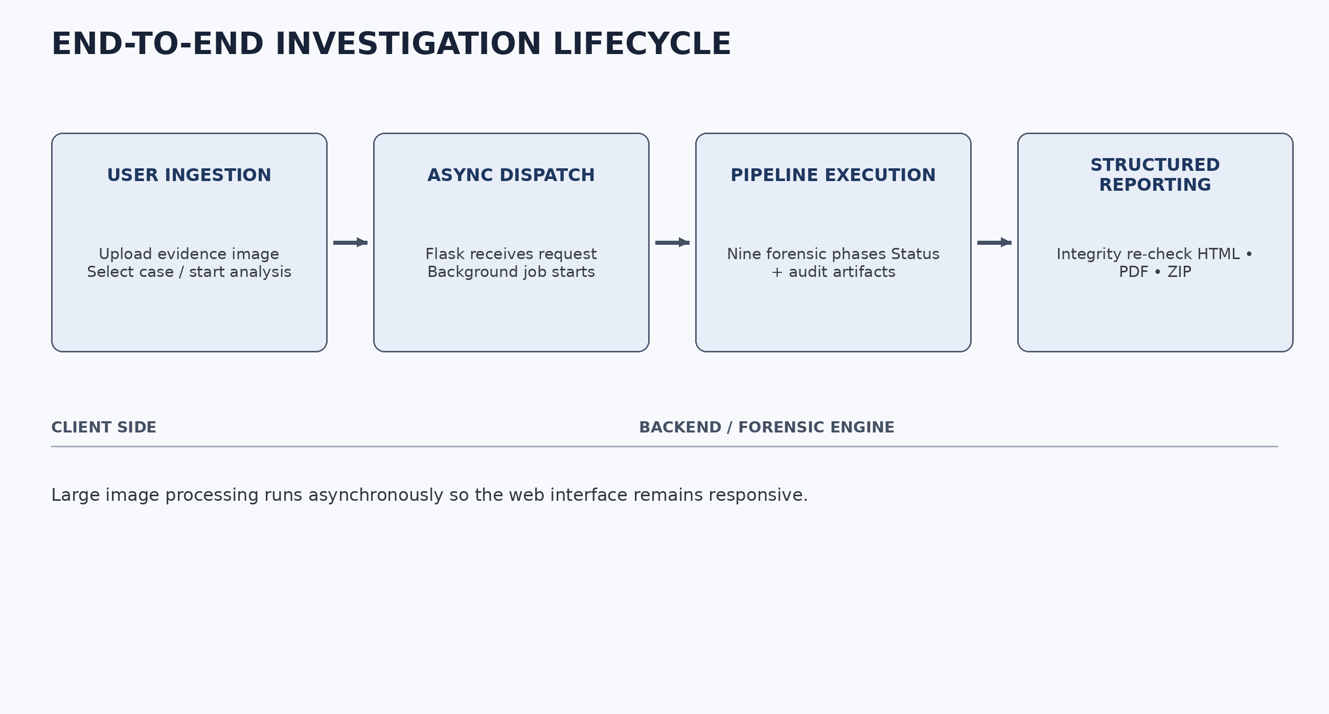
Figure 6.1: End-to-End Investigation Lifecycle (Client Operations vs. Backend Engine Execution)

7. Operational Security, Safety & Threat Mitigation
Digital forensics analysis involves handling untrusted disk images that may contain live exploit payloads, malware samples, or malicious filenames. DFA-14 integrates five defensive security layers:
Security Domain | Threat Vector | Architectural Defense Mechanism | Operational Implementation
Subprocess Safety | Command Injection via crafted filenames or metadata | Argument Vector Execution (Zero shell=True) | All subprocess.run() calls pass explicit tokenized argument lists: ['mmls.exe', image_path]. Zero shell=True.
Malware Isolation | Accidental malware detonation during recovery | Non-Executable Storage & Read-Only Attributes | Recovered files in recovered_files/ are stored without execute permissions.
Antivirus Handling | Windows Defender automated quarantine / locking | Exclusion Path Configuration | Administrators execute: Add-MpPreference -ExclusionPath '<case-vault-folder>' prior to analysis.
Network Boundary | Unauthorized remote access to evidentiary reports | Local Loopback Binding Only | Flask is strictly configured to bind to local loopback (localhost), preventing unauthorized LAN/WAN network exposure.
Output Sanitization | Cross-Site Scripting (XSS) & Template Injection | Automatic Template Escaping & Strict Typing | Jinja2 autoescaping is enforced on all dynamic strings; ReportLab XML tags are escaped.

8. Empirical Experimental Results & Benchmarks
DFA-14 underwent rigorous empirical testing across two distinct test corpora to validate accuracy, performance, and evidentiary reproducibility:
Forensic Metric / Parameter | Corpus 1: practice_evidence.dd (FAT12) | Corpus 2: image.E01 (NTFS GPT)
Input Container Type | Raw Bitstream Floppy (.dd) | Expert Witness Format (.E01)
File Size | 1.44 MB (1,474,560 bytes) | 309.2 MB (324,239,360 bytes)
Primary Partition Offset | Sector 0 (Offset: 0 bytes) | Sector 65664 (Offset: 33,620,016 bytes)
File System Architecture | FAT12 (Legacy Floppy) | NTFS (GPT Basic Data Partition)
Total Pipeline Runtime | 35.41 seconds | 246.62 seconds (4 min 6 sec)
Timeline Records Extracted | 73 file events | 5,800 events (839 deleted inodes)
Recovered Inode Files | 12 files | 3,982 files
Disguise / Extension Alerts | 2 disguised files (_ISGUISE.TXT) | 705 heuristic alerts (705/709 benign)
Keyword Search Hits | 41 keyword occurrences | 1,153 keyword occurrences
Case Deliverables Verified | 13 file paths present & verified | 13 file paths present & verified
Compressed Archive Size | 1.1 MB ZIP package | 343 MB ZIP package
Pre/Post Cryptographic Integrity | PASS (100% SHA-256 / MD5 match) | PASS (100% SHA-256 / MD5 match)

Cryptographic Verification: Both test runs achieved a PASS rating on post-analysis integrity verification. In both cases, the pre-analysis SHA-256 and MD5 hashes computed in Phase 2 matched the final post-analysis hashes with 100% bit-for-bit parity, proving that zero spoliation occurred during the 9-phase examination.

9. Technical Discrepancies & Analytical Findings
During live system testing and validation, five key technical discrepancies and forensic nuances were observed:

Discrepancy 1: MBR vs. GPT Partition Offsets
Initial historical documentation assumed standard Master Boot Record (MBR) partitioning with the primary NTFS partition beginning at Sector 2048 (1,048,576 byte offset). In live testing on image.E01, mmls revealed a GUID Partition Table (GPT) with Sector 34 allocated to Microsoft Reserved and Sector 65664 (33,620,016 byte offset) allocated to the primary NTFS Basic Data partition. The pipeline dynamically extracts the actual starting sector from mmls output rather than assuming static offsets.

Discrepancy 2: Deleted Inodes vs. Extracted Recovered Files
In testing on image.E01, fls -r enumerated 839 deleted directory records, whereas tsk_recover -e extracted 3,982 files. This is not an error. fls only indexes directory table records marked with a deletion flag ('d/d *'). tsk_recover -e recovers both allocated and unallocated data clusters, orphan inodes, and internal system metadata streams across the entire partition volume.

Discrepancy 3: Extension Mismatch False Positives (705 of 709 Flags)
The heuristic detector flags files whose internal MIME type does not match their file extension whitelist. On image.E01, 705 out of 709 flags were plain-text Windows configuration files (.url web shortcuts, .manifest files, and .eml messages). These are benign plain text, but because their extension is not .txt or .log, they trigger a heuristic alert. Forensic examiners must correlate these alerts with parent directory paths.

Discrepancy 4: Autopsy Headless Automation Watchdog
Autopsy 4.23.1 is a large Java NetBeans platform. On Windows 11, headless GUI process initialization required between 30 and 45 seconds. The pipeline's 25-second watchdog timer (AUTOPSY_TIMEOUT_SECONDS = 25) expired as designed and automatically failed over to native Sleuth Kit C binaries, completing the case without interruption.

Discrepancy 5: Case Deliverable Path Accounting
The pipeline unit test verifies 13 file paths on disk, representing 12 distinct output filenames (because it validates both original/<filename> and working/<filename>). All 13 paths were verified present and non-empty.

10. Conclusion & Recommendations
Digital Forensics Analyzer (DFA-14) successfully demonstrates that comprehensive digital forensics investigations can be automated end-to-end without sacrificing evidentiary rigor, cryptographic integrity, or investigative depth. By enforcing software read-only protection, streaming cryptographic dual-hashing, native Sleuth Kit integration, resilient Autopsy failover, and structured reporting modeled on ISO/IEC 27037 principles, the platform provides a robust, production-ready forensic foundation for academic labs and enterprise incident response.

Operational Recommendations for Instructors & Lab Administrators
• Antivirus Exclusions: Always execute 'Add-MpPreference -ExclusionPath <case-vault-folder>' prior to analysis to prevent antivirus locking during Phase 5 recovery.
• Practice Image Deployment: Distribute practice_evidence.dd for introductory labs (35s runtime) and reserve large E01 images for advanced capstone examinations (4-minute runtime).
• Grading Rubric Alignment: When evaluating student worksheets, award credit based on logical forensic reasoning and empirical evidence matching rather than strict single-value matching.

